EXP NO 5: Create a simple cloud software application for Library book reservation system for SIMATS library using any Cloud Service Provider to demonstrate SaaS.

AIM: To Create a simple cloud software application for Library book reservation
system for SIMATS library using any Cloud Service Provider to demonstrate
SaaS.
PROCEDURE:

Step1: go to zoho.com
Step 2: login to the zoho.com
Step 3: Create an application and open it.
Step 4: give a name as library system to the application and add a form in the name Book Details application.
Step 5: Add the required fields like book name, cost , ..etc.
Step 6:Click done and run the application.

OUTPUT:

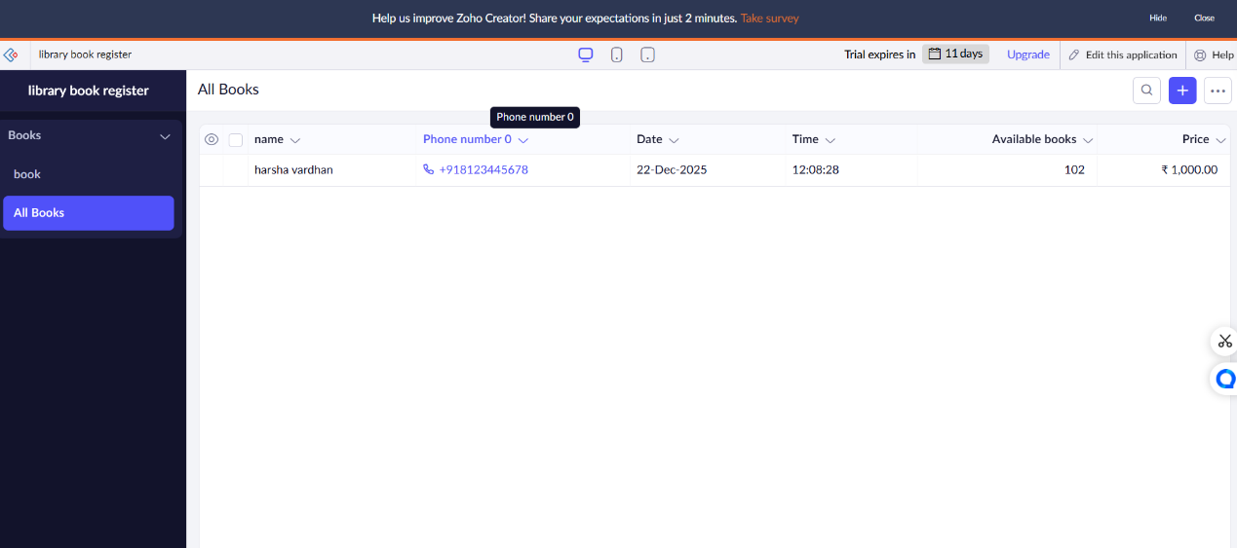

RESULT:

We have sucessfully created a simple cloud software application for library reservation system using any cloud service provider to demonstrate saas.

